导航Navigation
网站首页Home Page
关于中能Sinominingmach
产品中心Products
工程案例Projects
新闻中心News
配件与服务Parts and Service
人才招聘Recruitment
联系我们Contact us

产品分类与具体产品名字
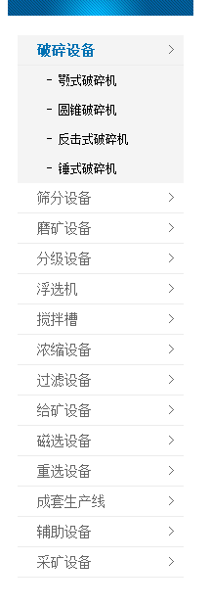
Crushing Equipment( Jaw Crushers, Cone Crusher, Impact Crusher, Hammer Crusher)
Screening Equipment
Grinding Equipment
Classifying Equipment
Flotation Machinery
Agitation Tank
Thickening Equipment
Filtration Equipment
Feeding Equipment
Magnetic Seperator
Gravity Concentration Equipment
Complete production line
Supplementary Machinery
Mining Machinery

工程案例具体信息与参数
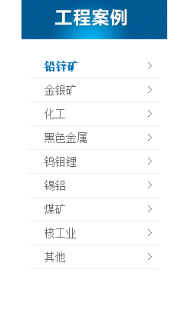
Lead, Zinc
Gold, Silver
Chemical Industry
Ferrous Metal
Tungsten, Molybdenum, Lepidolite
Stannum, Aluminium
Coal
Nuclear Industry
Others

